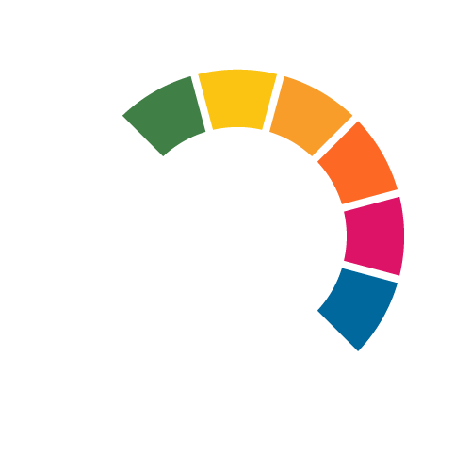
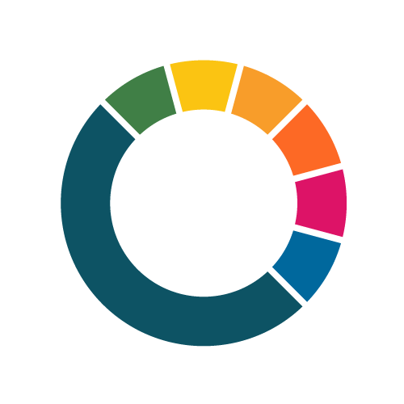
Call for Proposals:
Call for Pilot Cities, Cohort 2 (2023) – NetZeroCities

Impact Section Template

Name of Your Project/City

This document covers proposals for funding under Horizon Europe, Grant Agreement number: HORIZON-RIA-SGA-NZC-101121530

Call Opens: 5 September 2023, 12.00 CEST
Deadline: 6 November 2023, 17.00 CET
Call ID: NZC-SGA-HE-202309
Publication Date: 5 September 2023

netzerocities.eu

Table of Contents
Introduction to NZC PCP Impact Framework Template 4
1 Direct Impacts 6
1.1 Long-term GHG Impacts (Standardised) 6
1.2 Long-term GHG Impacts (Customised according to city/project) 7
2 Indirect Impacts or Co-benefits 8
2.1 Co-benefits (Standardised) 8
2.2 Co-benefits (Customised according to city/project) 9
3 Outcomes to unlock pathways to climate-neutrality 10
3.1 Early and Later Outcomes (Customised according to city/project) 10

Introduction to NZC PCP Impact Framework Template
Introduction and guidance (please go through this section before filling the template):
- This template summarises the ‘Impact’ section of your application. Please fill in this word document while also referring to the NZC PCP Indicator Set, and upload it in the sub-section ‘IMPACT’ in the Plaza portal as part of the submission of your application.
- The questions and tables outlined in this template are based on the overall structure and basic elements of the NZC Impact Framework (see diagram below). The information requested here is designed to help your proposal highlight the multi-dimensional progress your Pilot activities’ are expected to achieve, and to help your city gain strategic learnings and insights from your transformative journey through the NZC Pilot Cities Programme.
- The impacts, outcomes and indicators listed in this document will only be used at this stage of the Call for evaluating your proposal, based on the Call’s selection criteria. The contents of this template can be amended in the subsequent stages of the Programme for Monitoring, Evaluation & Learning (MEL) purposes, should your application be successful.

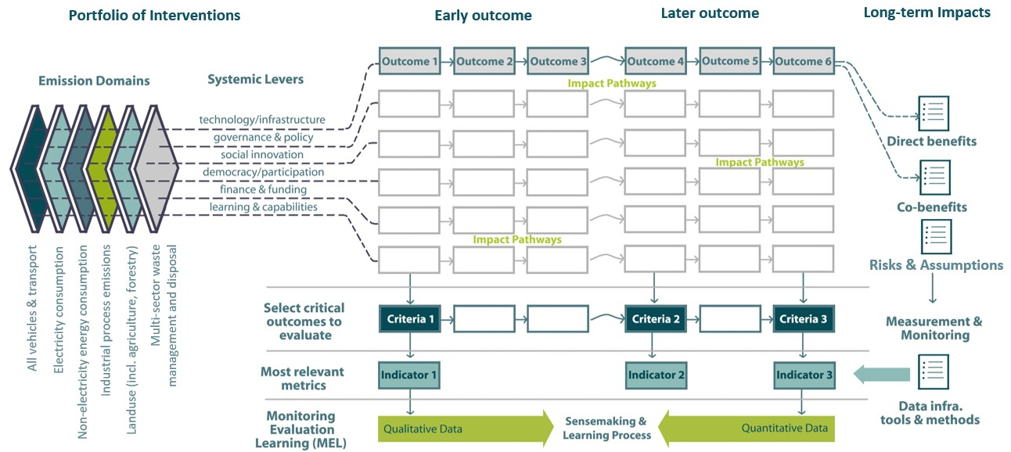

- The indicators/outcomes requested in this template are classified into three main categories based on the type of impacts and allowing for ample options for your proposal to communicate to the evaluators how your Pilot activities envision and define progress (“what does success look like?”). Once selected, this information will help chosen Pilot Cities assess their evidence needs, baseline/target values, and data sources for specific indicators/outcomes at a later stage of the PCP MEL process. These impact categories include:
- Direct Impacts are the long-term quantified effects produced by the project activities/interventions related to the GHG mitigation/reduction in one or more emission domains for the city.
- Indirect Impacts or Co-benefits expected to be produced during or after the project duration (either qualitative or quantitative) because of the Pilot activities/interventions. These also include long-term non-GHG impacts, if any.
- Intermediate Outcomes are the qualitative and observable changes/insights related to the process of implementing the portfolio, produced either early (short-term) or later (medium-term) during the project timeline. Some of these effects may potentially occur beyond the direct scope of your Pilot activities (for e.g., wider capacities built, or citizens engaged). These changes also relate your project’s Impact Logic or Impact Pathways that link short-term or medium-term outcomes to long-term direct/indirect impacts – to support meaningful connections and better coordination between individual activities. In essence, these outcomes will change the enabling conditions beyond the direct scope of the Pilot activities, to advance your city in your pathways to climate-neutrality. These qualitative outcomes will also be useful to better collect and frame your project/city’s strategic learnings and insights during implementation, as well as productively participate in the Collective Sensemaking process with other peer Pilot Cities in the cohort.
- The first two indicator categories for Direct and Indirect Impact above are further sub-divided into two sub-categories, to allow for greater flexibility and choice for indicator selection, data reporting and offering MEL guidance: These indicator sub-categories include:
- Standardised Indicators are the ones you are requested to select from the NZC PCP Indicator Set (available in the application pack). This set includes a catalogue of 36 indicators (12 GHG Indicators and 24 Co-benefits) compiled by the NZC Consortium, as recommended indicators as aligned with your proposal. These indicators are also compatible with the climate reporting platforms cities currently use (such as, CDP/ICLEI Track or MyCovenant), which can help Pilot Cities identify their relevant data sources at a later reporting stage. This indicator sub-category data will help us offer further MEL and impact assessment guidance to selected Pilot Cities, allow for quantitative data comparability/aggregation between all Pilot Cities in the cohort, and enable capacity building within the PCP cohort.
- Customised Indicators are specific and most suited to your project based on your intended impacts and city’s context. These non-standardised or contextual indicators can be included to measure progress and assess impacts that are not explicitly covered in the NZC PCP Indicator Set provided. Applicants are free to describe them based on their Pilot activities and voluntarily report data based on them, if selected.
- Similarly, the information to be provided in the third main category of qualitative Outcomes is also contextual as descriptive text. They are classified as ‘Early’ or ‘Later’ Outcomes based on when they are expected to be produced i.e., whether in the short-term or medium-term. For further guidance on how to better frame these outcomes per lever or selected Impact Pathways, please refer to the NZC PCP Guidebook.
- Lastly, both the quantitative and qualitative indicators or outcomes supplied in this template should not be considered as finalised or frozen for the project’s MEL process post-selection, but rather a starting point for our collective Learning and Sensemaking journey for PCP. If selected, cities will have a chance to edit, refine or revise this information during the Grant Agreement preparation. At this stage, we recommend making an informed choice of a few key indicators, outcomes and impact narratives that best suit your city/project’s ambitions and envisioned impact, and best respond to the evaluation and selection criteria of this Call.

Direct Impacts
Question: How are the Pilot activities expected to reduce the city's GHG emissions? What is the intended impact and emissions decrease profile, over the duration of the Pilot activities, and as a proportion of the city's overall emissions profile? (Up to 500 words)

Please use the following section to capture the specific GHG and non-GHG long-term impacts and indicators for your Pilot activities or interventions.

Long-term GHG Impacts (Standardised)
Please use this section to capture the GHG and non-GHG long-term impacts of your Pilot activities or interventions and refer to NZC PCP Indicator Set for further details.
Activity or Intervention name | GHG Emission Domain | Emission Sub-domain | Quantitative indicator | Metric/unit of measurement  (How will this impact be measured?)
Please add as applicable | Select one or more from –  - All vehicles and transport (mobile energy)  - Consumption of electricity generated for buildings, facilities, & infrastructure  - Consumption of non-electricity energy for thermal uses in buildings & facilities  - Land use (including agriculture, forestry, and other land uses)  - Multi-sector waste management and disposal  - Industrial process emissions | Select from as applicable –  - GHG emissions  - Total GHG emissions  - Stationary energy  - Transport  - Waste  - Industrial processes and product use  - Agriculture, forestry, and land use (AFOLU)  - Grid supplied energy  - Energy Consumption  - Energy Efficiency  - Share of Renewable Energies  - Carbon capture and residual emissions | Select from the suggested list of 12 indicators in NZC PCP Indicator Set as applicable | Select from suggested list of units in NZC PCP Indicator Set or add your own as applicable
Please add/remove rows as applicable

  - Long-term GHG Impacts (Customised according to city/project)
Please use this section to capture the quantitative GHG impacts of your Pilot activities or interventions (those not included in NZC PCP Indicator Set).
Activity or Intervention name | GHG Emission Domain | Emission Sub-domain | Quantitative indicator | Metric/unit of measurement  (How will this impact be measured?)
Please add as applicable | Select one or more from –  - All vehicles and transport (mobile energy)  - Consumption of electricity generated for buildings, facilities, & infrastructure  - Consumption of non-electricity energy for thermal uses in buildings & facilities  - Land use (including agriculture, forestry, and other land uses)  - Multi-sector waste management and disposal  - Industrial process emissions | Please add your own as applicable | Please add your own as applicable | Please add your own as applicable
Please add/remove rows as applicable

Indirect Impacts or Co-benefits
Question: Which co-benefits or other indirect long-term impacts do the Pilot activities expect to achieve in your city, in addition to GHG-emissions reduction? (Up to 500 words)

Please use the following section to capture the specific co-benefits or long-term indirect impacts of your Pilot activities.

Co-benefits (Standardised)
Please use this section to capture the co-benefits of your Pilot activities or interventions and refer to NZC PCP Indicator Set for further details.
Activity or Intervention Name | Domain | Sub-domain | Quantitative or qualitative indicator | Metric/unit of measurement  (How will this impact be measured?)
Please add as applicable | Select from as applicable –  - Public Health and environment  - Social Inclusion, Innovation, Democracy and Cultural Impact  - Economy  - Resource efficiency  - Biodiversity | Select from 24 recommended Co-benefit Sub-domains from the NZC PCP Indicator Set | Select from the suggested list 24 of indicators in NZC PCP Indicator Set or add your own as applicable | Select from suggested list of units in NZC PCP Indicator Set or add your own as applicable
Please add/remove rows as applicable

Co-benefits (Customised according to city/project)
Please use the following section to capture the Co-benefits of your Pilot activities or interventions (those not included in NZC PCP Indicator Set).
Activity or Intervention name | Describe Co-benefit related to this activity or intervention | Emission Domain(s) | Lever(s) | Custom quantitative or qualitative indicator | Custom metric/unit of measurement (How will this impact be measured?)
Please add as applicable | Please add your own as applicable | Select one or more as applicable –  - All vehicles and transport (mobile energy)  - Consumption of electricity generated for buildings, facilities, & infrastructure  - Consumption of non-electricity energy for thermal uses in buildings & facilities  - Land use (including agriculture, forestry, and other land uses)  - Multi-sector waste management and disposal  - Industrial process emissions | Select one or more as applicable –  - Technology and infrastructure  - Governance and policy  - Financing and funding  - Social innovation  - Democracy and participation  - Learning and capabilities  - Data and digitalisation  - Procurement | Please add your own as applicable | Please add your own as applicable
Please add/remove rows as applicable

Outcomes to unlock pathways to climate-neutrality
Question: What or how do you think the Pilot activities will enable change in your city within and beyond their direct scope, on your pathway towards climate-neutrality? (Up to 750 words)

Please use the following section to outline your qualitative outcomes based on your Pilot activities. These descriptive outcomes should ideally also cover the changes beyond the direct scope of Pilot activities, for e.g., how will the long-term change and its momentum be sustained beyond the 2-year project timeline? For detailed explanations on Impact Pathways and what do we mean by Early (short-term) or Later (medium-term) Outcomes, please refer to the ‘NZC Theory of Change’ or previous webinars on the topic of ‘impact pathways’ or ‘MEL’ on the NZC Portal.

Early and Later Outcomes (Customised according to city/project)
Activity or Intervention name | Select relevant Lever(s) of Change | Describe an Early Outcome related to this activity or intervention. | Describe a Later Outcome related to this activity or intervention, beyond the direct scope of the activity.
Please add as applicable | Select one or more as applicable –  - Technology and infrastructure  - Governance and policy  - Financing and funding  - Social innovation  - Democracy and participation  - Capacities and capabilities  - Data and digitalisation  - Procurement | Please describe as applicable | Please describe as applicable
Please add/remove rows as applicable

