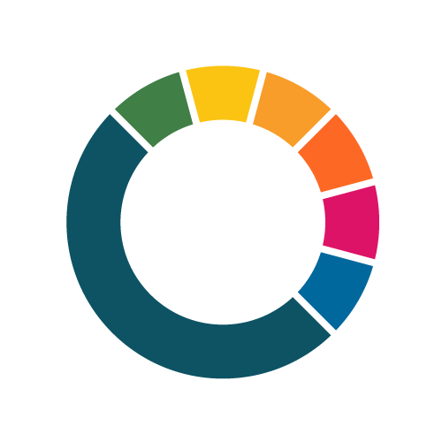
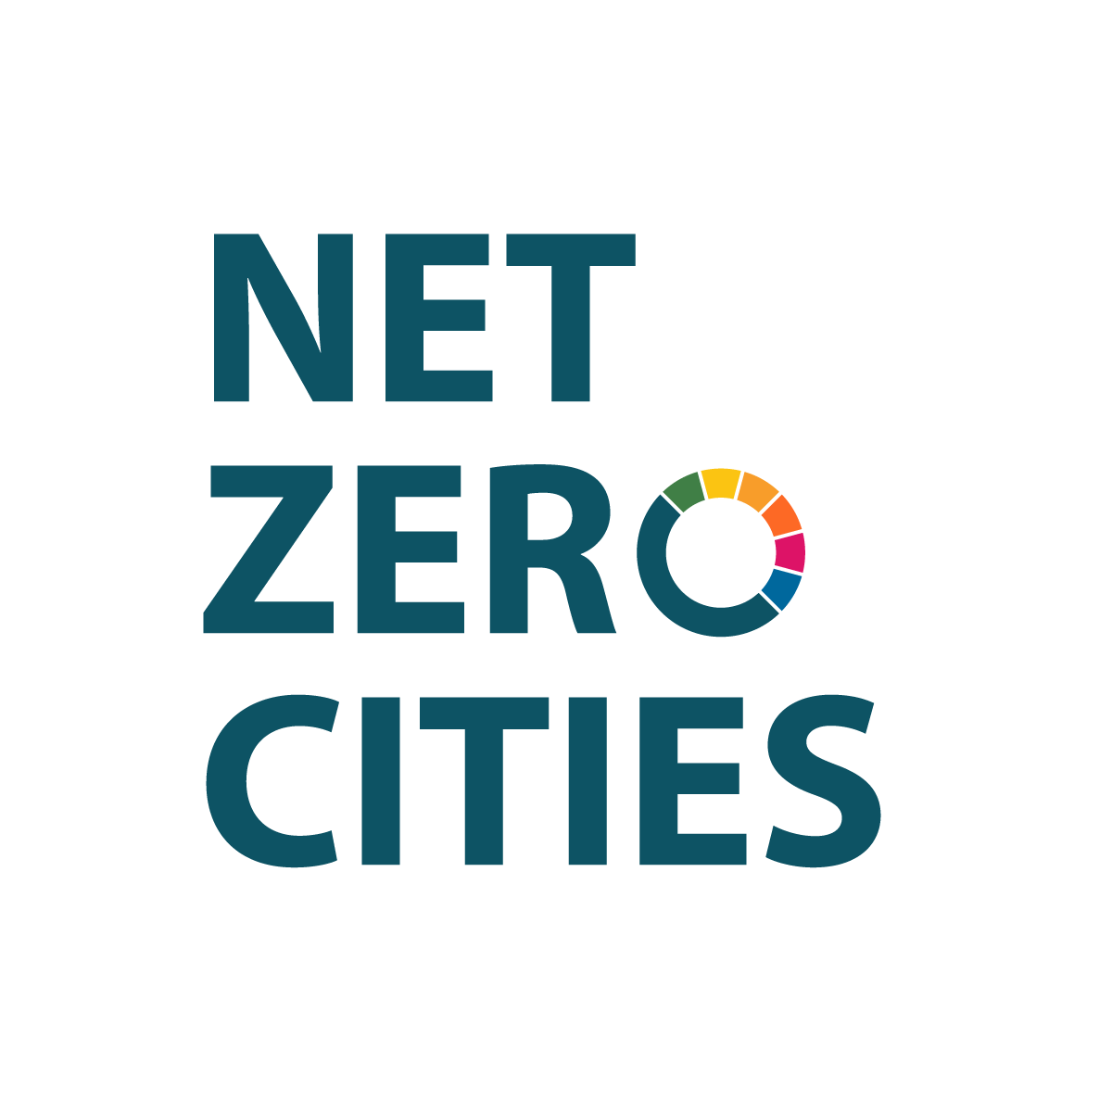
Open call –

Leveraging Innovation & Financing for Transformation Call Application Template

This template supports proposals for funding under Horizon Europe, Grant Agreement number: HORIZON-RIA-SGA-NZC-101121530

Call Opens: 28 July 2026, 12.00 CEST
Deadline: 24 August 2026, 17.00 CEST
Call ID: NZC-SGA-HE-202607

Publication Date: 28 July 2026

Contents
1. Introduction 3
2. Application Details 3
2.1. Description 3
2.2. Project acronym (Optional but recommended when the project title is long) 3
2.3. Is this a multi-Mission-city application? 3
2.4. City department (or equivalent) engagement 4
2.5. Stakeholders 4
2.6. Emissions domains / Levers of change associated with this proposal 4
3. Alignment to eligible activities 5
3.1. Leveraging Innovation & Financing for Transformation Alignment – eligible activities 5
3.2. EU Dimension and complementary activities 5
4. Mandate to Act 6
4.1. Articulating the challenge(s) 6
4.2. Mandate to Act 6
4.3. Consortium and stakeholders 7
5. Capacity to Act 7
5.1. Capacity and capability 7
5.2 Sound work plan and budget 7
5.3 Cross-cutting considerations 8
5.4 Citizen engagement and participation 8
6 Impact 9
6.1 Innovativeness & Learning 9
6.2 Impact 9
6.3 Enabling innovation interventions’ replication and transferability 10
7 Declarations and key word tags 10
7.1 Alignment to Leveraging Innovation & Financing for Transformation eligible activities 10
7.2 Other EU funded programmes/calls 10
7.3 Other EU funded programmes/Calls 10
7.4 Key word tags 10

Introduction
This template document is prepared for prospective applicants to draft offline, with consortium partners/stakeholders, their responses to the narrative parts of the application form. For completeness, templates are provided for download on the NetZeroCities website under the Leveraging Innovation & Financing for Transformation call page. The full list of templates includes:

- Proposal form (narrative) – this document
- Risks template (filled in directly in the Risks section in the application platform)
- Work Plan template (filled in the Work plan section in the application platform)
- Impact Framework template (to be attached in the files section in the application platform)
- Budget template (to be attached in the files section in the application platform)

The Proposal Form, Risk Assessment, and Work Plan templates are provided as supporting documents reflecting the corresponding sections of the application platform. Applicants should use these templates for reference only and complete the relevant information directly within the application platform. The Impact Framework, and Budget templates must be completed separately and uploaded to the Files section of the application platform prior to submitting the application.

If you have any questions about this or other template documents, please reach out to ect@netzerocities.eu.

Application Details

Description
(NB: this is found on the Proposal Details tab) - Please provide a summary of the proposed interventions. Briefly outline the implementation challenge(s) you aim to address, and how. What is your vision for the outcomes of this work? How will it enable cities to innovate and implement towards the Mission goal of climate neutrality (by 2030)? This will be used publicly to profile and describe the submissions received under this Call.

Project acronym (Optional but recommended when the project title is long)

Is this a multi-Mission-city application?
Please use the Yes/No options to indicate if there are multiple Mission Cities present in your proposal. If selecting "Yes", please note that you will be prompted to provide a rationale for the multi-city proposal and collaboration.

☐Yes
☐No

    - (If “Yes” to 1.2) Multi-city application rationale
Please provide a brief rationale for us to understand why these specific cities will be working together.

(Max. 2,500 characters)

City department (or equivalent) engagement
Please list participating city departments (or equivalent) committed to and relevant for the implementation of the enabling innovation interventions.

(Max. 2,500 characters)

Stakeholders
Please list engaged/to be engaged stakeholders for the implementation of your proposed enabling innovation interventions.

(Max. 2,500 characters)

Emissions domains / Levers of change associated with this proposal
(NB: The selection of relevant emissions domains/levers if found on the Proposal Overview tab) - Please note this is used as metadata to support the analysis of the relevance and diversity of applications.

Please identify the relevant emissions domains that your interventions may relate to, from the pick list provided.
- ☐ Consumption of electricity generated for buildings, facilities, and infrastructure
- ☐ Consumption of non-electricity energy for thermal uses in buildings and facilities (e.g., heating, cooking, etc.)
- ☐ All vehicles and transport (mobile energy)
- ☐ Industrial process emissions
- ☐ Multi-sector waste management and disposal
- ☐ Land use (including agriculture, forestry, and other land uses)

Please identify the relevant levers of/for change that your interventions will engage, from the pick list provided.
1. ☐ Technology / infrastructure
2. ☐ Social innovation
3. ☐ Finance and Funding
4. ☐ Governance and policy
5. ☐ Democracy and Participation
6. ☐ Learning and Capabilities
7. ☐ Data and Digitalisation
8. ☐ Procurement

Alignment to eligible activities

Leveraging Innovation & Financing for Transformation Alignment – eligible activities
Please identify where your interventions align with and link to the Leveraging Innovation & Financing for Transformation Programme's eligible activities, and provide a brief description.

3.1.1 Deploying technology, product, process, service, solution, policy, governance model
Pioneering activities to support climate-neutrality, including the deployment of innovative (new or improved) technology, product, process, service, solution, policy, or governance model at city level, explored in a cross-sectoral and systemic manner.

☐Yes
☐No

(If yes) Please briefly describe the alignment of proposed pilot activities to the selected eligible activities (max 2500 characters)

3.1.2 Deployment of public and private capital in purpose-built capital structures
Deployment of public and private capital in purpose-built capital structures that enable blended financing in the implementation activities.

☐Yes
☐No
(If yes) Please briefly describe the alignment of proposed pilot activities to the selected eligible activities (max 2500 characters)

3.1.3 Establishing new knowledge, building capacity and capabilities
Activities to support climate-neutrality to establish new knowledge and build capacity and capabilities of city government and associated local actors through training, workshops, and other forms of learning.

☐Yes
☐No

(If yes) Please briefly describe the alignment of proposed pilot activities to the selected eligible activities (max 2500 characters)

3.1.4 Legal and financial expertise to structure/audit and de-risk project financial packages

☐Yes
☐No

(If yes) Please briefly describe the alignment of proposed pilot activities to the selected eligible activities (max 2500 characters)

EU Dimension and complementary activities
    - EU, national, regional policy alignment
Please briefly outline how the proposed interventions connect to, align with, and are complementary to, ambitious EU, national and/or regional policy and strategy, such as the EGD, the Climate Pact, the New European Bauhaus and the Horizon Europe climate-neutral cities Mission.

(Max. 2,500 characters)

    - Complementarity/building upon existing pilot activities?
If/where the proposed interventions build upon and/or complement existing pilot activities (across the three cohorts), whether or not these are the applicant city/ies’ own pilot activities, please provide a brief overview, including any learnings and insights drawn from these to date.

(Max. 2,500 characters)

Mandate to Act

Articulating the challenge(s)
    - Enabling implementation challenge(s)
Please describe the implementation challenge(s) your activities propose to address, and the enabling innovation opportunity this presents for you. How are the challenge(s) and enabling innovation opportunity relevant to the city/ies in the proposal?

(Max. 5,000 characters)

    - Strategic connectivity to city vision
How do the proposed interventions connect to the city's/ies' overarching vision for climate neutrality, and in particular the articulated challenges that the interventions will focus on, in the context of wider climate neutrality ambitions?

(Max. 2,500 characters)

    - Relevance of implementation challenge(s) and enabling innovation to other EU Cities
Please describe how and why the proposed challenge(s) to be addressed, and enabling innovation interventions proposed, are relevant to European cities and the Mission goals. How will other European cities learn and benefit from your proposed interventions and/or outcomes?

(Max. 5,000 characters)

Mandate to Act
    - Political mandate of proposed interventions
Please elaborate on how your proposed activities will build on and retain a strong political mandate - both throughout the life of the programme and beyond. Where relevant, please refer to any published documentation to support your answer. (Please only provide links to/upload documents that support the answer; in the case of large files/documents, please be specific about where evaluators should look in these documents.)

(Max. 2,500 characters)

Letter(s) of Support
Please confirm that you have completed the upload of your Letter(s) of Support in the Files section of this submission platform.
☐ Yes
☐ No

Consortium and stakeholders

    - Consortium and relevant stakeholders/contributors
Please outline what partners and other stakeholders will the city be engaging/working with, and what relevant expertise, experience, competencies, and/or positionality they bring to the proposed interventions. Please also describe how you will engage / work with them.
.

(Max. 5,000 characters)

Capacity to Act

Capacity and capability

    - Capability and capacity building
Please describe how the (consortium and strategic) partners and stakeholders will collectively generate, share, and retain knowledge, know-how, skills, and partnerships, from the proposed interventions, beyond the life of the programme. How will you generate and retain capability and capacity together, through this work?

(Max. 5,000 characters)

    - Implementation and Operational readiness
Please describe how city and partners are ready to initiate implementation, including how governance management and coordination arrangements required to deliver the interventions are established and fit for purpose.

(Max. 5,000 characters)

    - Delivery at pace and effective mobilisation
Please describe how city and partners can quickly generate meaningful results whilst activating, aligning and leveraging existing capabilities, assets and commitments within the project consortium

(Max. 2,500 characters)

Sound work plan and budget
    - Sound work plan: Please confirm you have completed the Work Plan tab in the application platform
Please follow instructions on how/where to input the Work Plan into the Work Plan tab of the application platform. Please refer to the Work Plan Template to support offline drafting, as desired.

☐ Confirmed
☐ Not yet

    - Budget: Please confirm you have uploaded your budget (Excel template) into the Files section in this application form/platform
Please follow instructions on how/where to upload the Budget template in the Files section

☐ Confirmed
☐ Not yet

    - Financial plan for implementing the interventions (in budget and over the eighteen-month grant timeframe):
Please outline how you will ensure the implementation of the proposed interventions in budget and to the eighteen-month grant timeframe. This refers to ensuring the financial viability of the activities, and a plan for monitoring and adjusting implementation over the course of the grant period. If/where the interventions described constitute a part or parts of a larger city project/intervention, please outline how will you finance the activities that are beyond the scope of those included in this proposal, upon which the latter are dependent.

(Max. 5,000 characters)

    - Please confirm that you have completed the Risk Register in the Risks tab
Please follow instructions on how/where to input the risks into the Risk tab of the application platform. Please refer to the Risks Template to support offline drafting, as desired.

☐ Confirmed
☐ Not yet

Cross-cutting considerations
    - Cross-cutting considerations (relate)
In what way do your proposed interventions relate to issues and/or opportunities of diversity, inclusion, gender dimension, accessibility, and/or a just transition?

(Max. 2,500 characters)

    - Cross-cutting considerations (approach)
How will you approach and cater to these considerations and potential impacts/effects (indirect or otherwise) during the implementation, and ensure proposed interventions align with the Do No Significant Harm (DNSH) principle?

(Max. 2,500 characters)

Citizen engagement and participation
    - Citizen engagement and participation
If/where relevant and applicable, how will you engage citizens in the relevant stages of interventions and how will the engagement materially contribute to enabling innovation (design and implementation).

(Max. 2,500 characters)

Impact

Innovativeness & Learning
    - Innovativeness & Learning
please describe how the proposal demonstrates how it could generate new knowledge, insights or delivery models relevant to other Mission Cities and demonstrates a clear commitment to capturing, applying and sharing learning throughout implementation

(Max. 2,500 characters)

Impact
    - Direct Outcomes of interventions
Please describe early and later changes of the interventions and how these are expected to lead to longer-term impacts in enabling innovation and implementation.

(Max. 5,000 characters)

    - Approach to integrated MEL
Please identify and describe the approach to integrated monitoring, learning and evaluation (MEL): Relevant quantitative or qualitative indicators and a coherent process to monitor and continuously assess both the direct outcomes of interventions (targeted changes) and long-term impacts on GHG emissions and Co-benefits, have been included, and a description of how the MEL approach will be implemented.

(Max. 5,000 characters)

6.2.3 Long-term targeted impacts
How does the proposal articulate the enabling innovation and expected impacts that will lead to reduction in GHG emissions and identify quantified impacts on GHG emissions that would be unlocked by the successful outcome(s) deployed at city-scale? Are co-benefits listed?
(Max. 2,500 characters)

6.2.4 Please confirm you have uploaded your Impact Framework Template into the Files section in this application form/platform.
You will find the Impact Framework Template and the Indicator Set on the call website.

☐ Confirmed
☐ Not yet

6.2.5 Please add foreseen Total greenhouse gas emission reduction (t CO2 equivalents / year)
This indicator will be reported on top of the indicators planned in the Impact Framework. Please put here the proposal's goal in terms of total emission reductions.

Enabling innovation interventions’ replication and transferability
    - Replication (speed)
Please describe how the interventions, if/where successful, may be replicated and deployed rapidly (at speed) across the EU, in support of Mission goals and the target for 2030 climate neutrality. What about the enabling innovation intervention(s), if successful, lends itself to replication, at speed?

(Max. 2.500 characters)

    - Transferability (scale)
Please describe how the interventions, if/where successful, may be transferred across the EU, in different contexts, in support of Mission goals and the target for 2030 climate neutrality. What about the enabling innovation intervention(s), if successful, lends itself to transferability, at EU-scale?

(Max. 2.500 characters)

Declarations and key word tags

Alignment to Leveraging Innovation & Financing for Transformation eligible activities
I hereby declare the proposed interventions' are aligned to Leveraging Innovation & Financing for Transformation Call's eligible activities.
☐ I declare
☐ I do not declare

Other EU funded programmes/calls
I hereby declare that funding requested through this NetZeroCities Leveraging Innovation & Financing for Transformation programme application does not result in the double-funding of existing, EU funded activities.
☐ I declare
☐ I do not declare

Other EU funded programmes/Calls
Please identify any other EU funded programmes/Calls you either have or intend to apply to in the area of the outlined interventions in this proposal (i.e. similar proposal). Please specify any overlaps and complementarities: these may become important in the definition and finalisation of any future grant agreement.

(Max. 5,000 characters)

Key word tags
Please enter up to five key words / short phrases (try to keep to max 2-3 words, if not 1) that summarise the intention and ambition of your proposed interventions, in the following short text fields.

- Key Word Tag 1: Please enter a key word / short phrase (try to keep to max 2-3 words, if not 1) that helps to summarise the intention and ambition of your proposed interventions
- Key Word Tag 2: Please enter a key word / short phrase (try to keep to max 2-3 words, if not 1) that helps to summarise the intention and ambition of your proposed interventions
- Key Word Tag 3: Please enter a key word / short phrase (try to keep to max 2-3 words, if not 1) that helps to summarise the intention and ambition of your proposed interventions
- Key Word Tag 4: Please enter a key word / short phrase (try to keep to max 2-3 words, if not 1) that helps to summarise the intention and ambition of your proposed interventions
- Key Word Tag 5: Please enter a key word / short phrase (try to keep to max 2-3 words, if not 1) that helps to summarise the intention and ambition of your proposed interventions

