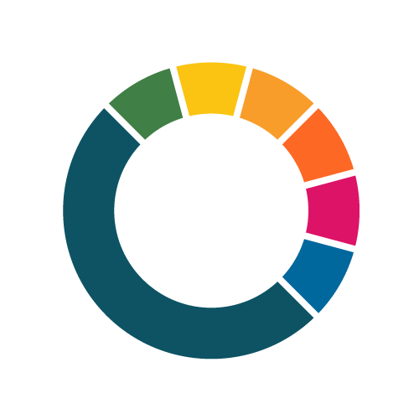
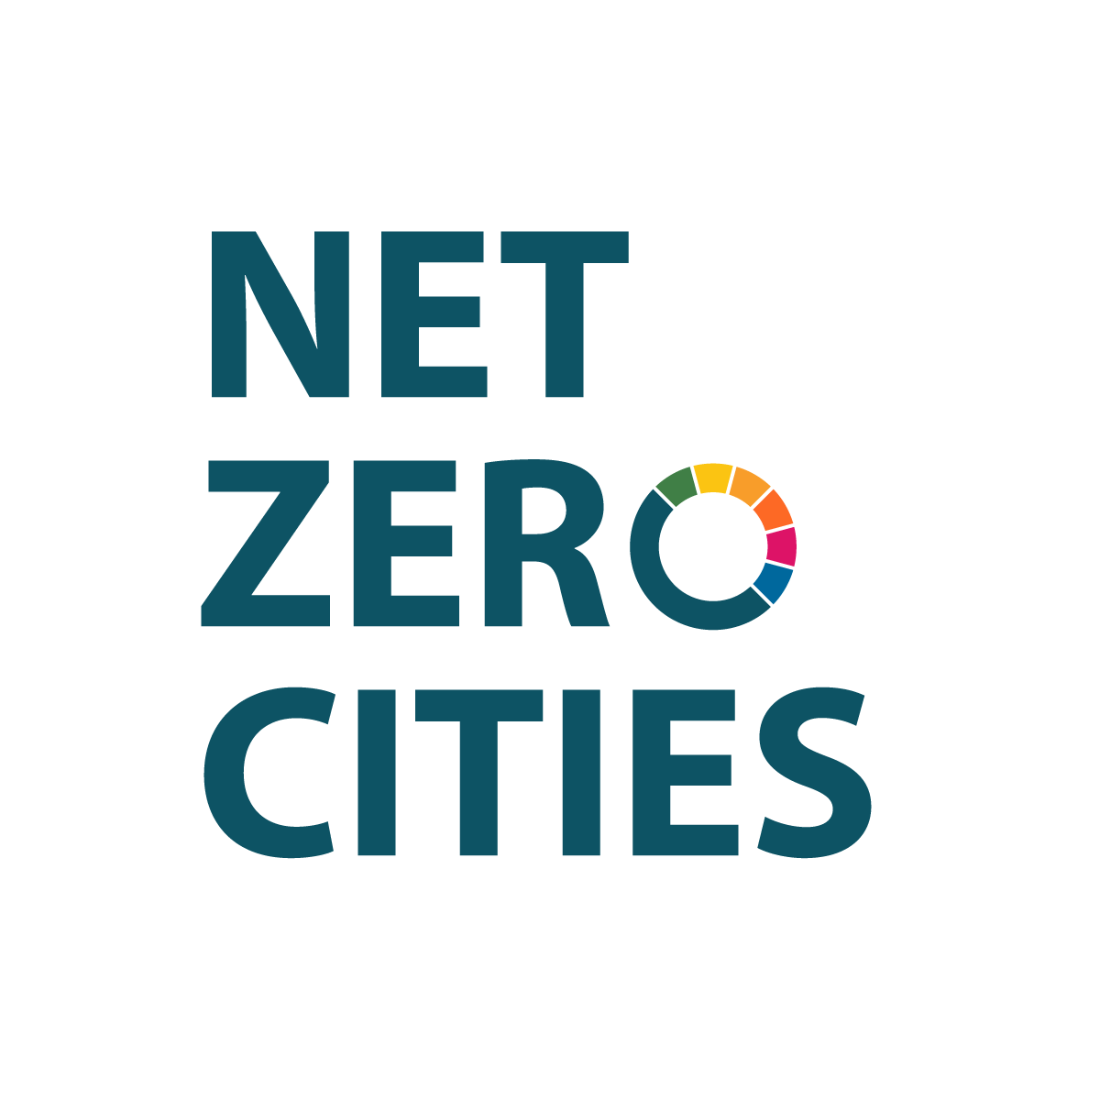
Call for proposals: NetZeroCities Enabling City Transformation 2

Call Application Template

This template supports proposals for funding under Horizon Europe, Grant Agreement number: 101261829 — SGA3-NZC

Call Opens: 31 August 2026

Deadline: 3 December 2026

Call ID: NZC-SGA3-HE-202608

Publication Date: 31 August 2026

netzerocities.eu

Contents
1. Introduction 3
2. Proposal Details 4
2.1 Description 4
2.2 Expected outcomes 4
3. General information 4
3.1 Emission Domains 4
3.2 Levers for change 4
3.3 Organisation Roles 5
3.4 Project Roles 5
4. Proposal form 5
4.1 Application details 5
Primary Challenge Area 5
Secondary Challenge Area (Optional) 5
Challenge Area Rationale 6
Is this a multi-Mission-city application? 6
City department (or equivalent) engagement and delivery structure 6
4.2 Alignment to eligible activities 6
Enabling City Transformation Alignment – eligible activities. 6
4.3 Complementary activities and portfolio collaboration 7
4.4 Mandate to act 8
4.4.1 Challenge Area Alignment 8
4.4.2 Authority to Act 8
4.4.3 Strategic coherence with existing Mission commitments 8
4.4 Capacity to act 9
4.4.1 Credible delivery architecture 9
4.4.2 Finance and planning 9
4.4.3 Awareness of risks 10
4.4.4 Stakeholder engagement 10
4.4.5 Inclusion & Just Transition Integration 10
4.5 Impact 10
4.5.1 Lasting Outcomes 10
4.4.3 Impact Framework 11
4.5.2 Innovation and learning 11
4.4.4 Scaling and replication 11
4.6 Declarations and key word tags 12
Key word tags 12

Introduction
This template is issued to facilitate the preparation of the ECT2 proposal offline a in a collaborative way with consortium partners. The questions contained in this template mirror the proposal form on the grant management system. For completeness, templates are provided for download on the NetZeroCities website under the Enabling City Transformation 2 Programme call page. The full list of templates includes:

- Call Application template (narrative) – this document
- Work Plan template
- Risks template
- Letter of Support Template (NB: this file is to be completed and uploaded to the Files section of the application platform)
- Budget template (NB: this file is to be completed and uploaded to the Files section of the application platform)
- Impact Framework template (NB: this file is to be completed and uploaded to the Files section of the application platform)

The structure of this template reflects the Proposal structure on the grant management system and allows evaluation according to the selection criteria identified in the call guidelines.

To submit a proposal applicants will need to add information to the following sections:

This template will introduce the first three sections but focus on the “Proposal form” one.
Specifically for the Work plan and Risks section, it is possible to copy/paste content from the respective excel templates.

If you have any questions about this or other template documents, please reach out to ect@netzerocities.eu.

Proposal Details
This is the first section of the proposal containing high level information such as proposal name, name of the lead organisation, proposed funding amount,…
In this section the following narrative questions will be asked

2.1 Description
Please provide the high level summary description of the proposal including why the project is needed and who will benefit form it In this part also eventual consortium partners are introduced. Please provide a summary of the proposed interventions. Briefly outline the implementation challenge(s) you aim to address, and how. What is your vision for the outcomes of this work? How will it enable cities to innovate and implement towards the Mission goal of climate neutrality (by 2030)? This will be used publicly to profile and describe the submissions received under this Call.

Expected outcomes
Please write here the changes that the project aims to make and trigger are described. This question should contain a summary of what was included in section 1 of the Impact framework “Intended outcomes”.

General information
This section contains:

3.1 Emission Domains
Please note this is used as metadata to support the analysis of the relevance and diversity of applications.

Please identify the relevant emissions domains that your interventions may relate to, from the pick list provided.
☐ Consumption of electricity generated for buildings, facilities, and infrastructure
☐ Consumption of non-electricity energy for thermal uses in buildings and facilities (e.g., heating, cooking, etc.)
☐ All vehicles and transport (mobile energy)
☐ Industrial process emissions
☐ Multi-sector waste management and disposal
☐ Land use (including agriculture, forestry, and other land uses)

3.2 Levers for change
Please identify the relevant levers of/for change that your interventions will engage, from the pick list provided.
☐ Technology / infrastructure
☐ Social innovation
☐ Finance and Funding
☐ Governance and policy
☐ Democracy and Participation
☐ Learning and Capabilities
☐ Data and Digitalisation
☐ Procurement

3.3 Organisation Roles
Please add consortium organisations. All organisations need to be registered in the Grant Management System in advance. The application should be created and submitted by the Proposal Lead (Mission City). This questions allows to confirm the consortium eligibility criterion.

Organisation Name | Organisation Role | Organisation English Name
 | Proposal lead/Collaborator

3.4 Project Roles
Registered users can be added to the form in the proposal stage to act as collaborators. Please note that the submission of the application, and, later, the reports, can be conducted only by the Proposal Lead. Though it’s easier when project roles are added before application submission is possible to add other collaborators during programme implementation.

Name and surname | Proposal lead/Collaborator

Proposal form

4.1 Application details
Project acronym (optional)

Primary Challenge Area
All applicants must choose the one challenge area that resonates most and anchor the rationale for their intervention within it.
☐ Place-based heating and cooling
☐ Urban energy systems
☐ Large-scale building retrofits and renovations
☐ Nature-Based Solutions at city scale
☐ City finance innovations for climate neutrality
☐ Decarbonising urban mobility and logistics

Secondary Challenge Area (Optional)
Challenge areas are not silos – cities may work transversally (for example bringing nature-based solutions into a retrofit or heating programme, or using finance as the route into an emission-domain challenge). If your proposal spans a second area, indicate it here.
☐ Place-based heating and cooling
☐ Urban energy systems
☐ Large-scale building retrofits and renovations
☐ Nature-Based Solutions at city scale
☐ City finance innovations for climate neutrality
☐ Decarbonising urban mobility and logistics

Challenge Area Rationale
Please provide a brief rationale for us to understand why you have chosen the challenge area(s) above. Note; This is an overview only. Further details will be requested below. This questions allows to confirm the challenge area eligibility criterion

(Max. 2,000 characters)

Is this a multi-Mission-city application?
Please use the Yes/No options to indicate if there are multiple Mission Cities present in your proposal. If selecting "Yes", please note that you will be prompted to provide a rationale for the multi-city proposal and collaboration.
☐Yes
☐No

(If “Yes” above) Multi-city application rationale
Please provide a brief rationale for us to understand why these specific cities will be working together.

(Max. 2,000 characters)

City department (or equivalent) engagement and delivery structure
Please list participating city departments (or equivalent) committed to and relevant for the implementation of the enabling innovation interventions.

(Max. 1,500 characters)

4.2 Alignment to eligible activities

Enabling City Transformation Alignment – eligible activities.
Please identify where your interventions align with and link to the NZC Enabling City Transformation Programme's eligible activities (set out in section 5.4 of the Call Guidelines). Proposals may cover one or several categories. All activities must be framed in terms of what they are intended to change, rather than as isolated actions.

Pioneering activities: Deploying technology, product, process, service, solution, policy, governance model
Pioneering activities to support climate-neutrality, including the deployment of innovative (new or improved) technology, product, process, service, solution, policy, or governance model at city level, explored in a cross-sectoral and systemic manner.

☐Yes
☐No

(If yes) Please briefly describe the alignment of proposed activities to the selected eligible activities (Max. 2,000 characters)

Systemic, Science based Innovative Initiatives : the connection between research, evidence and city delivery
Systemic, science-based innovative initiatives that strengthen cities’ use of scientific research and ensure translation of research results into policy actions, to accelerate climate neutrality in the sectors/domains of water, food, energy, industry, housing and deep building retrofitting, transport, and mobility through the levers of green technology (i.e. digitalisation), behavioural/lifestyle change, social innovation, culture, policy and regulation, finance, and new business models (e.g., circular economy). These innovations shall account for co-benefits (e.g., health promotion) and the "Do No Significant Harm DNSH) principle.

☐Yes
☐No
(If yes) Please briefly describe the alignment of proposed activities to the selected eligible activities (Max. 2,000 characters)

Capacity and capability building activities: Establishing new knowledge, building capacity and capabilities
Activities to support climate-neutrality to establish new knowledge and build capacity and capabilities of city government and associated local actors through training, workshops, and other forms of learning.

☐Yes
☐No

(If yes) Please briefly describe the alignment of proposed activities to the selected eligible activities (Max. 2,000 characters)

Collaborative governance and community building activities
Activities aiming to build more collaborative communities, to advance new governance models at city level, and to engage citizens (including vulnerable/marginalised groups) and enable them to act on climate change in a systemic and cross-sectoral manner.

☐Yes
☐No

(If yes) Please briefly describe the alignment of proposed activities to the selected eligible activities (Max. 2,000 characters)

Communication, dissemination and exploitation of results (supporting activities)
Communication, dissemination and exploitation activities may be included where they support and amplify the outcomes and impact of delivery, contributing to knowledge transfer, replication, scaling, institutional adoption, peer learning and Mission-wide uptake of results. Note that these are supporting activities rather than a standalone eligible activity category.

☐Yes
☐No

(If yes) Please briefly describe the alignment of proposed activities (Max. 2,000 characters)

Complementary activities and portfolio collaboration
Building upon existing activity
If/where the proposed interventions build upon and/or complement existing pilot activities (across the three Pilot Cities Programme and Enabling City Transformation cohorts), whether or not these are the applicant city/ies’ own pilot activities, please provide a brief overview, including any learnings and insights drawn from these to date.

(Max. 2,000 characters)

Portfolio collaboration
Applicants are encouraged to signal existing collaborations with other Mission Cities on the selected challenge area and openness to collaboration across the ECT2 portfolio. Cities working within the same challenge area may be clustered for shared learning and cross-fertilisation. Please describe here, if any: what would you want to co-develop, test or share with other cities addressing your chosen challenge area, and what would you need from them? Please name specific methods, assets or outputs rather than a general willingness to collaborate.

(Max. 2,000 characters)

4.4 Mandate to act

4.4.1 Challenge Area Alignment

Local context & Diagnosed system blockers
Identify the primary type(s) of blocker driving the implementation challenge (for example institutional, policy, financial, market, capacity or data) that are preventing progress within your chosen challenge area. Demonstrate that these are a genuine system-level constraint rather than an isolated project gap, and show the link between the challenge area, the identified constraint and your proposed outputs. Please describe why the selected challenge area is relevant to the local context of the city(ies)

(Max. 5,000 characters)

4.4.2 Authority to Act

Political mandate of proposed interventions
Further to the submitted letter(s) of support, please elaborate on your city’s formal authority and political backing to implement the proposed changes, and how the proposed activities will build on and retain a strong political mandate both throughout the life of the programme and beyond. Where relevant, refer to published documentation; please only link to or upload documents that support the answer, and for large documents be specific about where evaluators should look.

(Max. 2,500 characters)

Letter(s) of support
Please confirm that you have completed the upload of your Letter(s) of Support in the Files section of the submission platform. In the case of a multi-city proposal, one letter must be provided for each city. Letters must use the applicant’s official document header, be signed and dated by an official mandated to sign on the city/mayor/city council’s behalf, name the Call, and include an unambiguous commitment to the ECT2 Programme and a declaration of learning exploitation. Please use the pro forma template provided. This questions allows to confirm the LoS eligibility criterion.
☐ Confirmed
☐ not yet

4.4.3 Strategic coherence with existing Mission commitments

Strategic connectivity to city vision
How do the proposed interventions connect to the city's/ies' overarching vision for climate neutrality (including a city’s climate city contract), and in particular the articulated challenge area that the interventions will focus on, in the context of wider climate neutrality ambitions? Please also outline how the interventions connect to, align with and are complementary to ambitious EU, national and/or regional policy and strategy.

(Max. 2,500 characters)

EU-level relevance: relevance of the implementation challenge and enabling innovation to other EU cities
Please describe how and why the challenge area to be addressed, and enabling innovation interventions proposed, are relevant to European cities and the Mission goals. How will other European cities learn and benefit from your proposed interventions and/or outcomes?

(Max. 2,500 characters)

Capacity to act

Credible delivery architecture

Consortium partners: roles, relevance, and contribution
Please outline the make-up of the consortium and the role each partner will undertake with regard to the proposed interventions. Explain how partners are well aligned with complementary roles that enable delivery, and how the consortium reflects the expertise, experience and competencies required. Set out how you will collaborate, and demonstrate that the proposed interventions are deliverable within the 22-month grant period and budget, with coherent value for money.

(Max. 3,000 characters)

Delivery and implementation mechanisms
Address your city’s current state (i.e. the current delivery, policy or institutional situation regarding this challenge area in your city) and briefly describe the delivery and implementation trajectory for your chosen challenge area, What specific change in delivery conditions are you aiming to achieve? This should demonstrate that the chosen challenge area is grounded in local context, evidence and delivery realities..

(Max. 2,500 characters)

4.4.2 Finance and planning

Sound work plan: Please confirm you have completed the Work Plan tab in the application platform
Please follow instructions on how/where to input the risks into the Risk tab of the application platform. Please refer to the Work Plan Template to support offline drafting, as desired.

☐ Confirmed
☐ not yet

Budget: Please confirm you have uploaded your budget (Excel template) into the Files section in this application form/platform
Please follow instructions on how/where to upload the Budget template in the Files section

☐ Confirmed
☐ not yet

Financial plan for implementing the interventions (in budget and over the 22-month grant timeframe):
Please outline how you will ensure the implementation of the proposed interventions in budget and to the 22-month grant timeframe. This refers to the financial viability of the activities, and to a plan for monitoring and adjusting implementation over the course of the grant period. If/where the interventions described constitute part of a larger city project or intervention, please outline how you will finance the activities beyond the scope of this proposal upon which the proposed interventions depend.

(Max. 3,000 characters)

Finance mobilisation strategy
Beyond the subgrant, describe any credible finance mobilisation strategies (public, private, blended or market-shaping) that support or extend delivery, and how the proposal aligns with existing city financial and budgetary systems.

(Max. 2,000 characters)

Mandatory budget features: please confirm that your budget includes the required programme features
Section 7.4 of the Call Guidelines sets out mandatory effort to be reflected in the budget. Please confirm that your budget includes: coordination effort and dedicated cost lines for the lead Mission City (including oversight of partners’ financial reporting); dedicated systemic innovation focal point; travel and subsistence provision for the Boot Camp and for the in-person Collective Sensemaking session; communication and dissemination activities and CFS audit costs.
☐ Confirmed
☐ not yet

4.4.3 Awareness of risks

Please confirm that you have completed the Risk Register in the Risks tab
Please follow instructions on how/where to input the risks into the Risk tab of the application platform. Please refer to the Risks Template to support offline drafting, as desired.

☐ Confirmed
☐ not yet

4.4.4 Stakeholder engagement

Stakeholder engagement and participation
Identify the stakeholders – including citizens, businesses and institutional partners where relevant – engaged at each relevant stage of the interventions. Explain how this engagement is durable, decision-linked and embedded in governance and delivery processes, and how it contributes meaningfully to delivery and decision-making rather than to consultation alone. Where citizen engagement specifically is not included, please provide a robust rationale for why it is not relevant to this proposal. This questions allows to confirm the stakeholders eligibility criterion.

(Max. 3,000 characters)

4.4.5 Inclusion & Just Transition Integration

Cross-cutting considerations: inclusion, just transition and Do No Significant Harm (DNSH)
In what way do your proposed interventions relate to issues and/or opportunities of diversity, inclusion, gender dimension, accessibility, and/or a just transition? How will you approach and cater to these considerations and potential impacts/effects (indirect or otherwise) during the implementation, and ensure proposed interventions align with the Do No Significant Harm (DNSH) principle?

(Max. 2,000 characters)

4.5 Impact

4.5.1 Lasting Outcomes

Institutionalisation and policy embedment
Name the specific instruments or mechanisms – for example an ordinance, standard, planning rule, procurement practice, budget line, staffing model or operational routine – that are expected to change as a result of this proposal, and explain the credible pathway through which the change becomes embedded in policy, governance arrangements, budgeting, procurement or operational practice beyond the duration of the project. Where city authority is limited, describe the credible route to informing national or EU-level frameworks.

(Max. 2,500 characters)

Sustainability of outcomes
Explain how the proposed activities will deliver sustainable, long-lasting change in how the city operates beyond the life of the programme.

(Max. 2,000 characters)

Co-benefits
Identify the credible social, economic, environmental or resilience-related co-benefits expected beyond your primary objectives. Please keep this answer high-level: the quantified co-benefit indicators and the approach to monitoring them are captured in the separate Impact Framework template, using the ECT2 Programme Indicator Set.

(Max. 2,000 characters)

GHG Impact Monitoring & Evidence
Please describe the approaches for monitoring or evidencing GHG impact.

(Max. 2,000 characters)

Please add foreseen Total greenhouse gas emission reduction (t CO2 equivalents / year)
This indicator will be reported on top of the indicators planned in the Impact Framework. Please put here the proposal's goal in terms of total emission reductions.

4.4.3 Impact Framework

Impact Framework: please confirm that you have completed and uploaded the Impact Framework template
Please confirm that you have completed and uploaded the Impact Framework template in the Impact section of the submission platform. The Impact Framework carries your intended outcomes, impact pathways and signals of progress, your mandatory standardised GHG and co-benefit indicators selected from the ECT2 Programme Indicator Set, any customised indicators, and your integrated MEL system. It forms part of the material assessed at Stage 2, including the quantification of GHG and co-benefit impacts and the credibility of your monitoring approach.

☐ Confirmed
☐ Not yet

4.5.2 Innovation and learning

Innovation and learning
What makes the proposed interventions “cutting edge” innovation? How will you capture, apply, share and disseminate new knowledge, data and insights on delivery models and innovative impact pathways throughout implementation with other Mission Cities?

(Max. 2,500 characters)

4.4.4 Scaling and replication
Scaling
Please describe how scaling the intervention would directly address or unblock the identified system constraint at larger scale, and how the interventions, if successful, may be replicated and deployed rapidly across the EU in support of Mission goals and the 2030 climate neutrality target. Please state your scaling ambitions as specifically and quantifiably as possible.

(Max. 2,500 characters)

Transferability
Please articulate what is predicted to be transferable in practice – beyond high-level lessons – to other Mission Cities and EU cities, and in different contexts (for example national or regional), in support of Mission goals and the 2030 climate neutrality target.

(Max. 2,500 characters)

Replicability What concrete, usable and well-specified replication outputs will you produce – for example a playbook, template, standard, model contract or toolkit? Please name them and describe who would use them and how. Note that subgrantees are required to deliver at least one knowledge asset in English for replication in another city.

(Max. 2,500 characters)

4.6 Declarations and key word tags
Alignment to NZC Enabling City Transformation 2 eligible activities
I hereby declare the proposed interventions' are aligned to the Enabling City Transformation Call's eligible activities.

☐ I do declare
☐ I do not declare

Other EU funded programmes/calls
I hereby declare that funding requested through this NZC Enabling City Transformation 2 programme application does not result in the double-funding of existing, EU funded activities.

☐ I do declare
☐ I do not declare

Other EU funded programmes/Calls
Please identify any other EU funded programmes/Calls you either have or intend to apply to in the area of the outlined interventions in this proposal (i.e. similar proposal). Please specify any overlaps and complementarities: these may become important in the definition and finalisation of any future grant agreement.

(Max. 1,500 characters)

Artificial intelligence (AI) use disclosure
Under this Call there is 100% human accountability for the content of the proposal, deliverables and reporting: human-led reasoning and direction is expected and AI should be a drafting assistant, not the author. Applicants must be transparent in disclosing which generative AI tools were used and how they were utilised. Proposals where there is evident and predominant use of AI will be penalised.
(Max. 1,000 characters)

Key word tags
Please enter up to five key words / short phrases (try to keep to max 2-3 words, if not 1) that summarise the intention and ambition of your proposed interventions, in the following short text fields.

Key Word Tag 1: Please enter a key word / short phrase (try to keep to max 2-3 words, if not 1) that helps to summarise the intention and ambition of your proposed interventions
Key Word Tag 2: Please enter a key word / short phrase (try to keep to max 2-3 words, if not 1) that helps to summarise the intention and ambition of your proposed interventions
Key Word Tag 3: Please enter a key word / short phrase (try to keep to max 2-3 words, if not 1) that helps to summarise the intention and ambition of your proposed interventions
Key Word Tag 4: Please enter a key word / short phrase (try to keep to max 2-3 words, if not 1) that helps to summarise the intention and ambition of your proposed interventions
Key Word Tag 5: Please enter a key word / short phrase (try to keep to max 2-3 words, if not 1) that helps to summarise the intention and ambition of your proposed interventions

