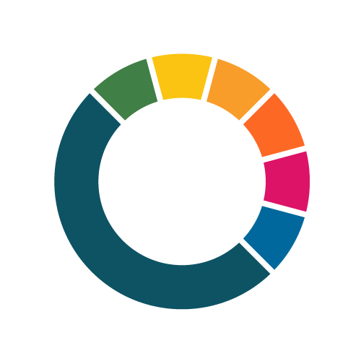




NetZeroCities Enabling City Transformation 2 (NZC ECT2)
Letter of Support template

This template supports proposals for funding under Horizon Europe, Grant Agreement number: 101261829 — SGA3-NZC

Call Opens: 31 August 2026
Deadline: 3 December 2026
Call ID: NZC-SGA3-HE-202608
Publication Date: 31 August 2026
netzerocities.eu

Authors: NetZeroCities Consortium coordinated by Climate-KIC

Disclaimer
The content of this document reflects only the author’s view. The European Commission is not responsible for any use that may be made of the information it contains.

Letter of support
Please find on the next page, a template for a letter of support which must be submitted as part of the application process. The letter of support must include the following:
- The letter must be from the city mayor (or equivalent) and/or any city official mandated to sign on behalf of the city/mayor/city council.
- The letter must be completed on the applicant’s official document header/template.
- The letter must be signed and dated by a city/district official mandated to sign on behalf of the city/mayor/city council.
- The letter must include the name and/or code of the Call [NetZeroCities Enabling City Transformation 2 / NZC-SGA3-HE-202608]
- The letter must include a statement that reflects an unambiguous commitment to collaborating and learning with other cities in the Enabling City Transformation 2 programme.

In the case of a multi-city application, please provide a letter of support for each participating city/district.

This letter must be written on the letterhead of city mayor or relevant authority.

Subject: NetZeroCities Enabling City Transformation 2 (NZC-SGA3-HE-202608): Letter of Support from (name of city mayor or relevant authority)

To the NetZeroCities Enabling City Transformation 2 Programme,
I, [name of mayor or relevant authority], hereby confirm on behalf of [name of municipality/local authority] our strong commitment and support for [project name], as submitted to the Call for Proposals for the NetZeroCities Enabling City Transformation 2 (NZC-SGA3-HE-202608).
[Briefly summarise the proposed interventions and goals.]
I declare [city/district] authority’s unambiguous commitment to the NetZeroCities Enabling City Transformation 2. We are dedicated to collaborating and learning with other successful cities should our proposal be selected for inclusion in the Enabling City Transformation 2 portfolio and to receive financial support (funding).
(Signature of mayor/relevant authority)
(Name of mayor/relevant authority)
(title)
(Address)

